Data Source: divvy_tripdata [accessed on 04/03/23]
#installing packages
install.packages("tidyverse")
library(tidyverse)
install.packages("modeest")
library(modeest)
library(dplyr)
library(ggplot2)
library(lubridate)
library(readcsv)

#collecting information
year2019 <- read_csv("Divvy_Trips_2019_Q1.csv")
year2020 <- read_csv("Divvy_Trips_2020_Q1.csv")

#?transformation of start/end station mutation to numeric format
year2019 <- mutate(year2019, from_station_id=as.numeric(from_station_id), to_station_id=as.numeric(to_station_id))
year2020 <- mutate(year2020, start_station_id=as.numeric(start_station_id), end_station_id=as.numeric(end_station_id))

#?transformation to date format
year2019 <- mutate(year2019, start_time=as.Date(start_time), end_time=as.Date(end_time))
year2020 <- mutate(year2020, started_at=as.Date(started_at), ended_at=as.Date(ended_at))

#adding day, week and month

year2019$d <- as.Date(year_2019$start_time)
year2019$m <- format(as.Date(year_2019$d), "%m" )
year2019$d <- format(as.Date(year_2019$d), "%d")
year_2019$day_of_week <- format(as.Date(year_2019$d), "%a")

#removing unecessary columns
year_2019 <- year_2019 %>% select(-c(tripduration, bikeid, from_station_id, from_station_name, to_station_id, to_station_name))

#trip duration
year2019$trip_duration <- difftime(year2019$end_time, year2019$start_time)

#dropping NA lines
year2019_na <- drop_na(year2019)

#number of dropped rows
365069-345357=19712

#dropping negative values
year2019_d_n <- year2019_d[year2019_d$tripduration>0,]
nrows=345357
#using function aggregate to find difference between subscribers and customers in mins
aggregate(year2019_d_n$tripduration/60 ~ year2019_d_n$usertype, FUN=mean)
1 Customer 37.02064
2 Subscriber 13.85694

aggregate(year2019_d_n$weekday~year2019_d_n$usertype, FUN=mfv)
#using statistical model to see which days are most popular
1 Customer Sat
2 Subscriber Thu

aggregate(year2019_d_n$tripduration/60 ~ year2019_d_n$member_casual + year2020$wid, FUN=mean)
year2019_d_n$usertype year2019_d_n$wd year2019_d_n$tripduration
1 Customer Fri 2291.2963
2 Subscriber Fri 831.5879
3 Customer Mon 1981.8979
4 Subscriber Mon 876.5452
5 Customer Sat 2304.1052
6 Subscriber Sat 1017.5365
7 Customer Sun 2597.7100
8 Subscriber Sun 1002.4099
9 Customer Thu 2436.3763
10 Subscriber Thu 718.3761
11 Customer Tue 1889.0932
12 Subscriber Tue 861.3484
13 Customer Wed 1726.3519
14 Subscriber Wed 722.7948

#exploring features

aggregate(year2019_d_n$wd~year2019_d_n$usertype, FUN=mfv)
year2019_d_n$wd <- ordered(year2019_d_n$wd, levels=c("Sunday", "Monday", "Tuesday","Wednesday", "Thursday", "Friday", "Saturday" ))
aggregate(year2019_d_n$tripduration ~ year2019_d_n$usertype + year2019_d_n$wd, FUN=mean)
year2019_d_n %>% mutate(weekday=wday(start_time, label=TRUE)) %>% group_by(usertype, weekday) %>% summarise(number_of_rides=n(), average_dur=mean(tripduration)) %>% arrange(usertype, weekday)
usertype weekday number_of_rides average_dur
<chr> <ord> <int> <dbl>
1 Customer Sun 976 2598.
2 Customer Mon 568 1982.
3 Customer Tue 783 1889.
4 Customer Wed 628 1726.
5 Customer Thu 784 2436.
6 Customer Fri 874 2291.
7 Customer Sat 1321 2304.
8 Subscriber Sun 23988 1002.
9 Subscriber Mon 48161 877.
10 Subscriber Tue 57928 861.
11 Subscriber Wed 57521 723.
12 Subscriber Thu 63519 718.
13 Subscriber Fri 59244 832.
14 Subscriber Sat 29062 1018.

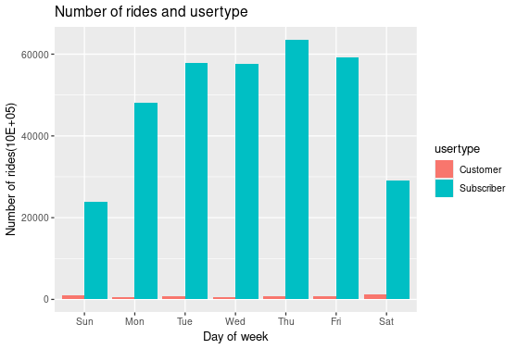

## Average duration

year2019_d_n %>% mutate(weekd=wday(start_time, label=TRUE)) %>% group_by(usertype, weekd) %>% summarise(number_of_rides=n(), average_dur=mean(tripduration)) %>% arrange(usertype, weekd) %>%
ggplot(aes(x=weekd, y=average_dur, fill=usertype)) + geom_col(position="dodge") + labs(title="Average duration and usertype") + ylab("Average duration") + xlab("Day of week")

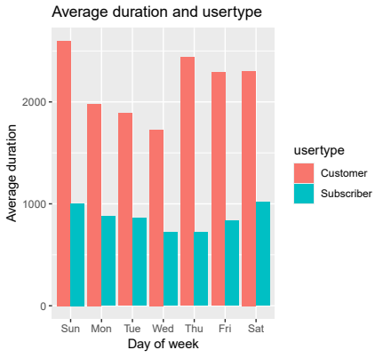

## Number of rides by month and usertype

year2019_d_n %>% mutate(weekd=wday(start_time, label=TRUE)) %>% group_by(usertype, weekd) %>% summarise(number_of_rides=n(), average_dur=mean(tripduration)) %>% arrange(usertype, weekd) %>%
ggplot(aes(x=weekd, y=average_dur, fill=usertype)) + geom_col(position="dodge") + labs(title="Average duration and usertype") + ylab("Average duration") + xlab("Day of week")

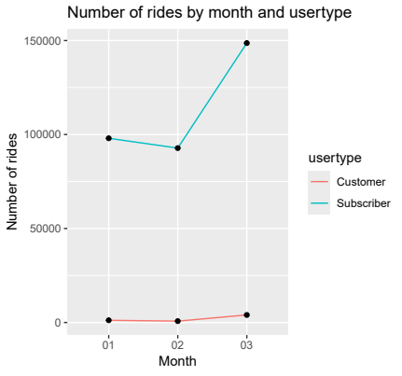

# year2020 initialising data
year2020 <- read_csv("Divvy_Trips_2020_Q1.csv")

# changing format of data
year2020 <- mutate(year2020, start_station_id=as.numeric(start_station_id), end_station_id=as.numeric(end_station_id))

# adding new columns for date, day of week and month
year2020$d <- as.Date(year2020$started_at)
year2020$m <- format(as.Date(year2020$d), "%m" )
year2020$day <- format(as.Date(year2020$d),"%d")
year2020$wd <- format(as.Date(year2020$d),"%a")

# removing unnecessary columns
year2020 <- year2020 %>% select(-c(start_lat, start_lng, end_lat, end_lng))

# adding column tripduration and calculating length of a trip
year2020 <- read_csv("Divvy_Trips_2020_Q1.csv")

# removing NA rows
year2020 <- read_csv("Divvy_Trips_2020_Q1.csv")
dropped 1 row

# removing negative rows
year2020 <- year2020_d[year2020_d$tripduration>0,]

# look at summary
summary(year2020)

# look at time in minutes
summary(year2020$tripduration)/60
aggregate(year2020$tripduration/60 ~ year2020$member_casual, FUN=mean)
year2020$member_casual year2020$tripduration/60
1 casual 96.20008
2 member 12.67711

aggregate(year2020$tripduration/60 ~ year2020$member_casual, FUN=median)
year2020$member_casual year2020$tripduration/60
1 casual 21.283333
2 member 8.583333

# we can see which day is most popular
aggregate(year2020$wd ~ year2020$member_casual, FUN=mfv)
1 casual Sun
2 member Tue

# rides dependent of day of week
aggregate(year2020$tripduration/60 ~ year2020$member_casual + year2020$wid, FUN=mean)
year2020$member_casual year2020$wid year2020$tripduration/60
1 casual Fri 119.09372
2 member Fri 12.62207
3 casual Mon 74.71312
4 member Mon 12.97714
5 casual Sat 100.28593
6 member Sat 15.49982
7 casual Sun 95.17611
8 member Sun 15.82234
9 casual Thu 127.00249
10 member Thu 11.55388
11 casual Tue 84.95958
12 member Tue 11.53387
13 casual Wed 75.74903
14 member Wed 11.65894

# relations
year2020 %>% mutate(weekday=wday(started_at, label=TRUE)) %>% group_by(member_casual, weekday) %>% summarise(number_of_rides=n(), average_dur=mean(tripduration/60)) %>% arrange(member_casual, weekday)

member_casual weekday number_of_rides average_dur
<chr> <ord> <int> <dbl>
1 casual Sun 14886 95.2
2 casual Mon 4802 74.7
3 casual Tue 5244 85.0
4 casual Wed 5874 75.7
5 casual Thu 4851 127.
6 casual Fri 5133 119.
7 casual Sat 7480 100.
8 member Sun 35964 15.8
9 member Mon 61923 13.0
10 member Tue 69697 11.5
11 member Wed 63978 11.7
12 member Thu 61245 11.6
13 member Fri 55496 12.6
14 member Sat 30104 15.5

# Number of rides and day of week
year2020 %>% mutate(weekday=wday(started_at, label=TRUE)) %>% group_by(member_casual, weekday) %>% summarise(number_of_rides=n(), average_duration=mean(tripduration/60)) %>%
arrange(member_casual, weekday) %>% ggplot(aes(x=weekday, y=number_of_rides, fill=member_casual)) + geom_col(position="dodge") + labs(title = "Number of rides and usertype") +
xlab("Day of week") + ylab("Number of rides")

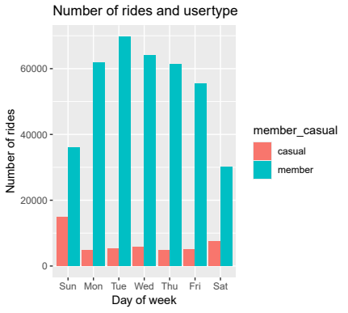

# Average duration and day of week

year2020 %>% mutate(weekday=wday(started_at, label=TRUE)) %>% group_by(member_casual, weekday) %>% summarise(number_of_rides=n(), average_duration=mean(tripduration/60)) %>%
arrange(member_casual, weekday) %>% ggplot(aes(x=weekday, y=average_duration, fill=member_casual)) + geom_col(position="dodge") + labs(title = "Average duration and usertype") +
xlab("Day of week") + ylab("Average duration(min)")

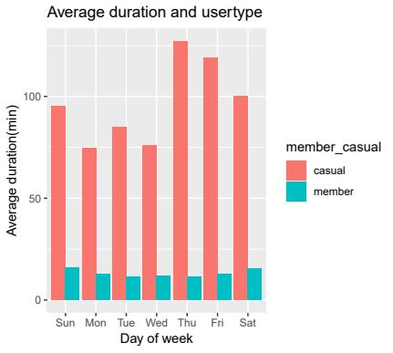

# Number of rides by bike type and usertype
year2020 %>% mutate(weekday=wday(started_at, label=TRUE)) %>% group_by(member_casual, rideable_type) %>% summarise(number_of_rides=n(), average_duration=mean(tripduration/60)) %>%
arrange(member_casual, rideable_type) %>% ggplot(aes(x=rideable_type, y=number_of_rides, fill=member_casual)) + geom_col(position="dodge") + labs(title = "Number of rides by usertype and bike type") +
xlab("Type of bike") + ylab("Number of rides")

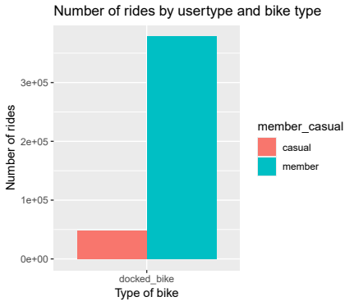

#Number of rides by usertype
year2020 %>% mutate(weekday=wday(started_at, label=TRUE)) %>% group_by(member_casual, weekday) %>% summarise(number_of_rides=n(), average_duration=mean(tripduration/60)) %>%
arrange(member_casual, weekday) %>% ggplot(aes(x=member_casual, y=number_of_rides, fill=member_casual)) + geom_col(position="dodge") + labs(title = "Number of rides by usertype") +
xlab("Usertype") + ylab("Number of rides")

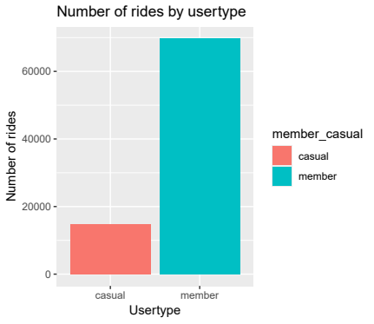

# Number of rides by month and usertype
year2020 %>% group_by(member_casual, m) %>% summarise(number_of_rides=n(), average_duration=mean(tripduration/60)) %>%
arrange(member_casual, m) %>% ggplot(aes(x=m, y=number_of_rides, group=member_casual)) + geom_line(aes(color=member_casual)) + labs(title = "Number of rides by month and usertype") +
xlab("Month") + ylab("Number of rides")

